Decision trees are one of the most popular and interpretable machine learning algorithms used for both classification and regression tasks. Their intuitive nature makes them an excellent choice for beginners in data science and machine learning. In this blog, we’ll delve into what decision trees are, how they work, and their advantages and limitations.

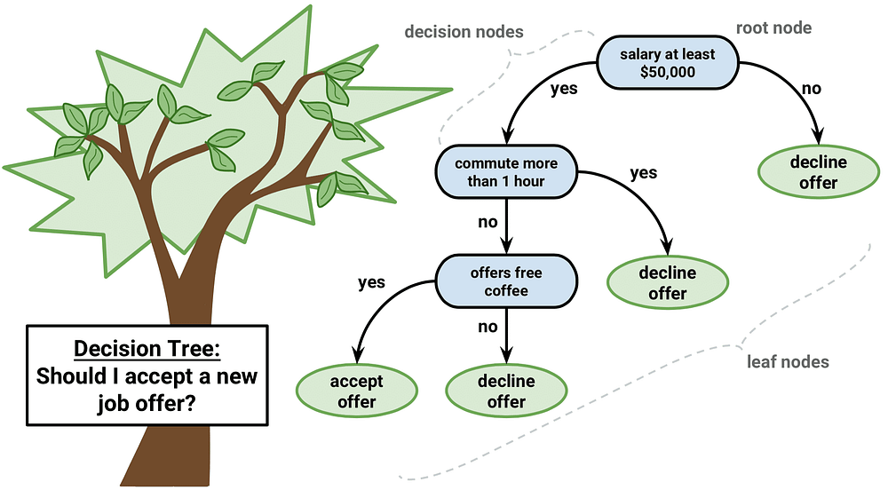

**What is a Decision Tree?**

A decision tree is a flowchart-like structure where each internal node represents a decision based on a feature, each branch represents the outcome of a decision, and each leaf node represents a final outcome or prediction. It mimics the human decision-making process by splitting data into subsets based on the most significant features.

**How Does a Decision Tree Work?**

1. **Splitting the Data**:
   * The algorithm starts by evaluating all possible splits for the data using a specific criterion (e.g., Gini Impurity, Information Gain, or Mean Squared Error).
   * It chooses the split that best separates the data into distinct classes or minimizes prediction error.
2. **Feature Selection**:
   * The feature that contributes the most to the predictive accuracy is selected for the root node.
   * This process is repeated recursively for the child nodes until a stopping condition is met.
3. **Stopping Criteria**:
   * Maximum depth of the tree.
   * Minimum number of samples required to split a node.
   * Minimum gain in information or reduction in impurity.
4. **Prediction**:
   * Once the tree is built, predictions are made by traversing the tree from the root to a leaf node based on the values of the input features.

**Key Concepts in Decision Trees**

1. **Entropy**:
   * A measure of the randomness or impurity in the data.
   * Lower entropy indicates a purer subset.
2. **Information Gain**:
   * The reduction in entropy achieved after a split.
   * The higher the information gain, the better the split.
3. **Gini Impurity**:
   * Measures the probability of incorrectly classifying a randomly chosen element.
   * A Gini Impurity of 0 indicates perfect classification.

**Advantages of Decision Trees**

1. **Interpretability**:
   * Decision trees are easy to understand and visualize, even for non-technical stakeholders.
2. **No Feature Scaling Needed**:
   * Unlike algorithms like logistic regression or SVM, decision trees do not require normalization or standardization of data.
3. **Handles Both Numerical and Categorical Data**:
   * Decision trees can work with mixed data types seamlessly.
4. **Non-parametric**:
   * They make no assumptions about the underlying data distribution.

**Limitations of Decision Trees**

1. **Overfitting**:
   * Decision trees tend to create overly complex trees that perform well on training data but generalize poorly on unseen data.
2. **Bias Toward Dominant Features**:
   * Features with many unique values can dominate the splitting process.
3. **Instability**:
   * Small changes in the data can lead to entirely different tree structures.
4. **Limited Accuracy**:
   * Decision trees are often outperformed by ensemble methods like Random Forests or Gradient Boosted Trees.

**Applications of Decision Trees**

1. **Customer Segmentation**:
   * Identify and group customers based on purchasing behavior.
2. **Fraud Detection**:
   * Classify transactions as legitimate or fraudulent based on patterns.
3. **Medical Diagnosis**:
   * Predict diseases or conditions based on symptoms.
4. **Risk Assessment**:
   * Evaluate risks in financial or insurance sectors.

**Tips for Working with Decision Trees**

1. **Prune Your Tree**:
   * Use techniques like pre-pruning (setting constraints during tree creation) or post-pruning (trimming branches after creation) to reduce overfitting.
2. **Experiment with Parameters**:
   * Adjust parameters like ‘max_depth’, ‘min_samples_split’, and ‘criterion’ to optimize your tree.
3. **Visualize the Tree**:
   * Use libraries like Scikit-learn or Graphviz to create visual representations of your decision tree.
4. **Combine with Ensembles**:
   * Use ensemble methods like Random Forests or Gradient Boosting to improve accuracy and robustness.

**Conclusion**

Decision trees are a versatile and interpretable machine learning tool that can be applied to various real-world problems. While they are prone to overfitting and instability, careful tuning and pruning can help mitigate these issues. For beginners, decision trees provide a great entry point into the world of machine learning, and their principles are foundational for understanding more advanced algorithms.